Mathematics: Specialist
Formula sheet Units 3A and 3B

Vectors

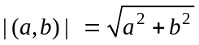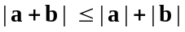
ab = |a| |b| cosѲ = a₁b₁+a₂b₂
Vector equation of a line in the plane:
one point and the slope: 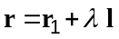
two points: 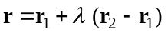
Vector form of the equation of a circle in the plane: |r – d| = ρ

Trigonometry

In any triangle ABC
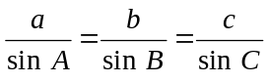 Area 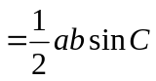
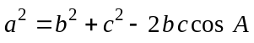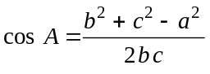
In a circle of radius r, for an arc subtending angle  (radians) at the centre:
Length of arc = 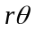 Area of sector = 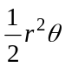 Area of segment = 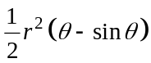

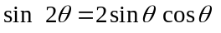
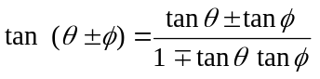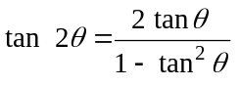

Exponentials and logarithms

For 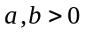and m ,n real,
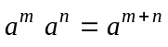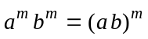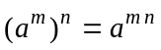
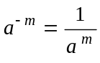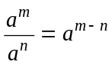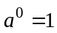
For m an integer and n a positive integer: 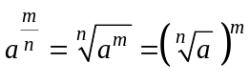

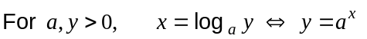
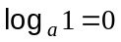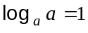
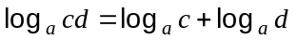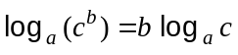

Functions
Differentiation
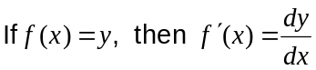
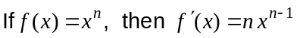
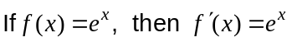
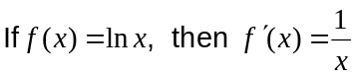

 | Function notation |  | Leibniz Notation
 |  | 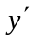
Product rule | 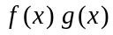 | 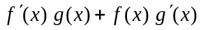 | 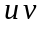 | 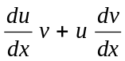
Quotient rule | 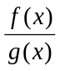 | 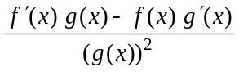 |  | 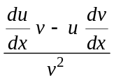
Chain rule | 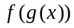 | 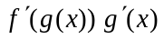 | 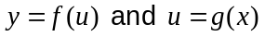 | 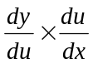

Integration
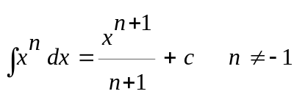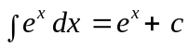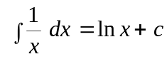

Fundamental Theorem of Calculus: 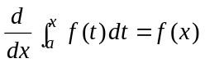and 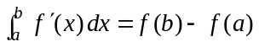
Piece-wise defined functions
Absolute value function: 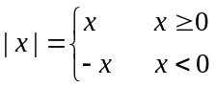

Sign function: 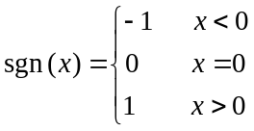
Greatest integer function: int (x) = greatest integer ≤ x for all x

Measurement
Trapezium: Area = 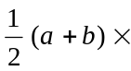height, where a and b are the lengths of the parallel sides
Prism: Volume = Area of base height
Cylinder: Total surface area = 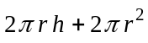 Volume = 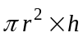
Pyramid: Volume = area of base height
Cone: Total surface area = 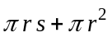, s is the slant height Volume = 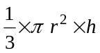
Sphere: Total surface area = 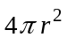 Volume = 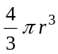
Note: Any additional formulas identified by the examination panel as necessary will be included in the body of the particular question.

